Cloud Watch is a monitoring tool

Metric Tool--->Graphs

Goto cloud watch service and click on create alarm

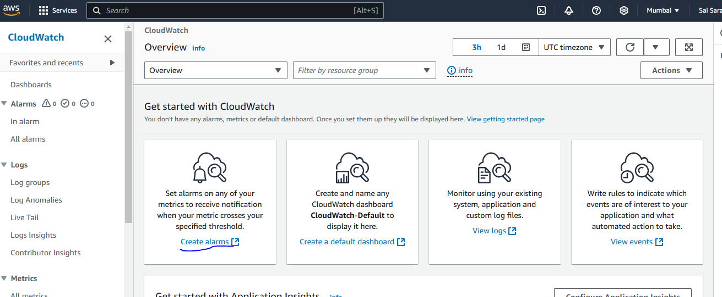

And then click on select metrics

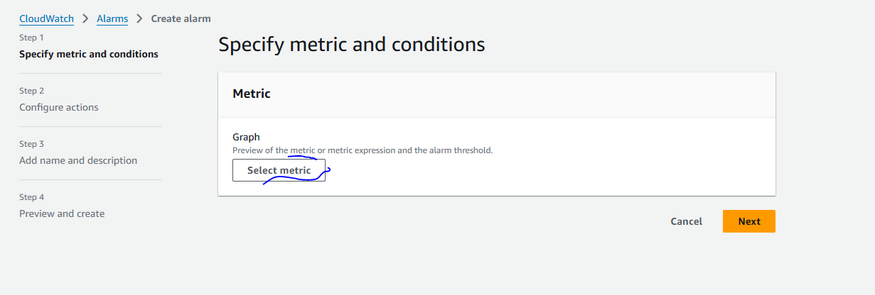

In that select any service in my case selected EC2

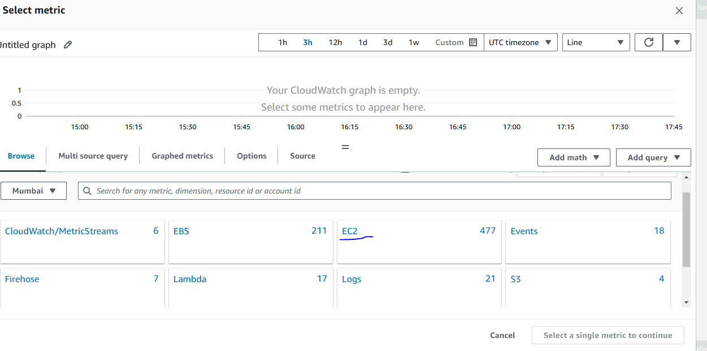

In service select any one metrics like any utilization and then click on select metrics

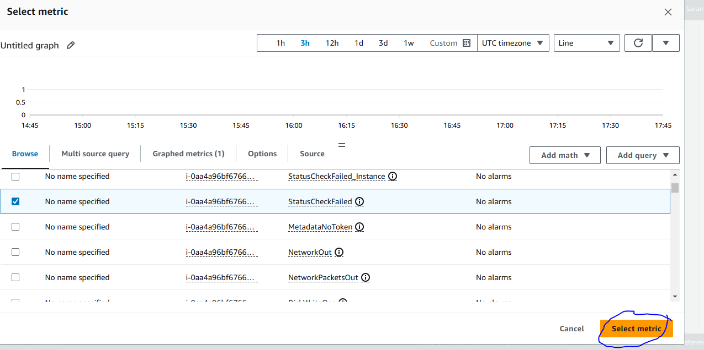

In next page give any time period

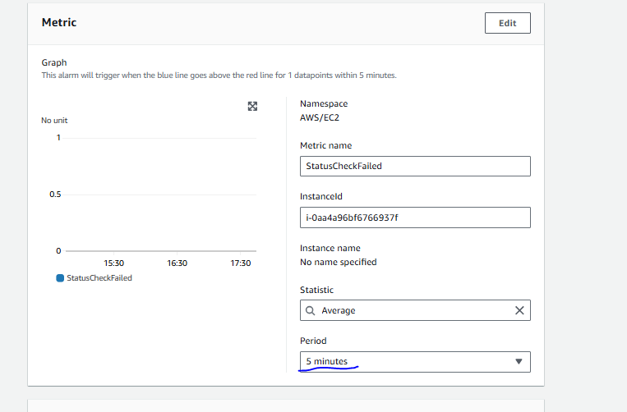

And in condition give any greater than threshold value

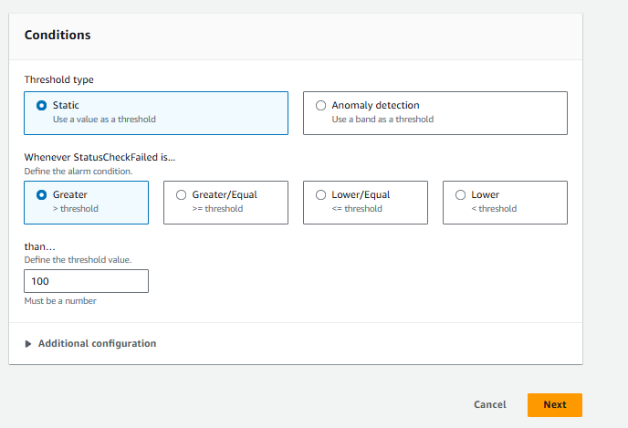

Next in configure action click on create topic in that

Give topic name

Give email Id which mail we need to receive notifications

Then click on create alarm

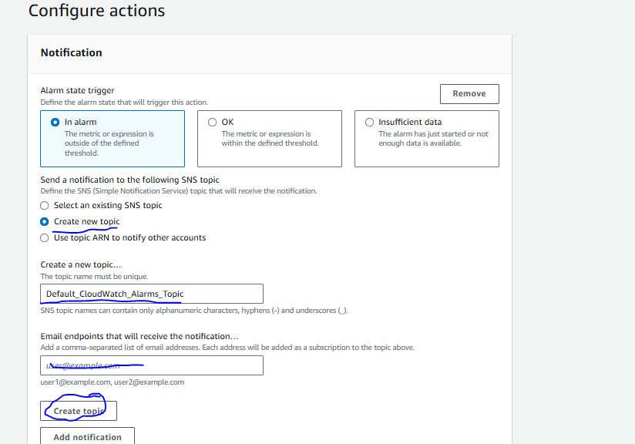

After creating alarm click on Next

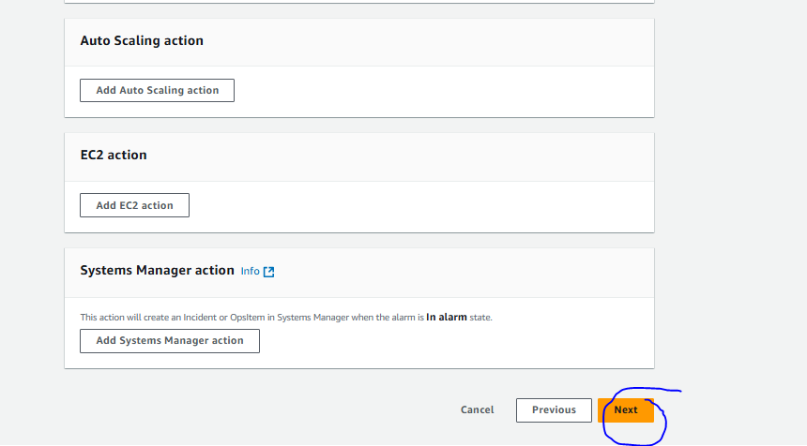

In next page Add name and description in that give alarm name and click on next

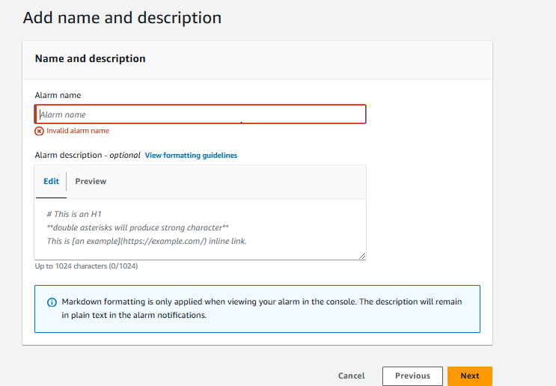

Then click on Next at last Review and create alarm

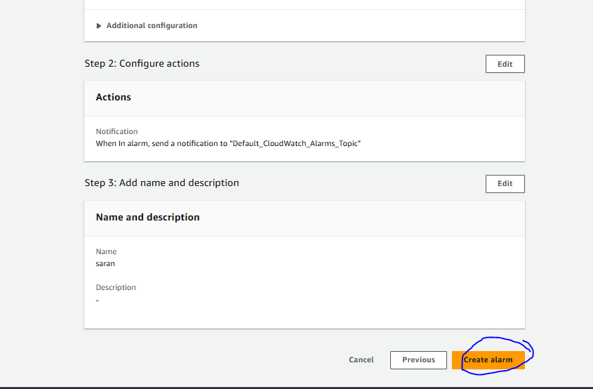

After creating check mail you will subscription mail then click on subscribe

